**Final Report**

**Applied Cryptography in Legacy Vehicle Networks**

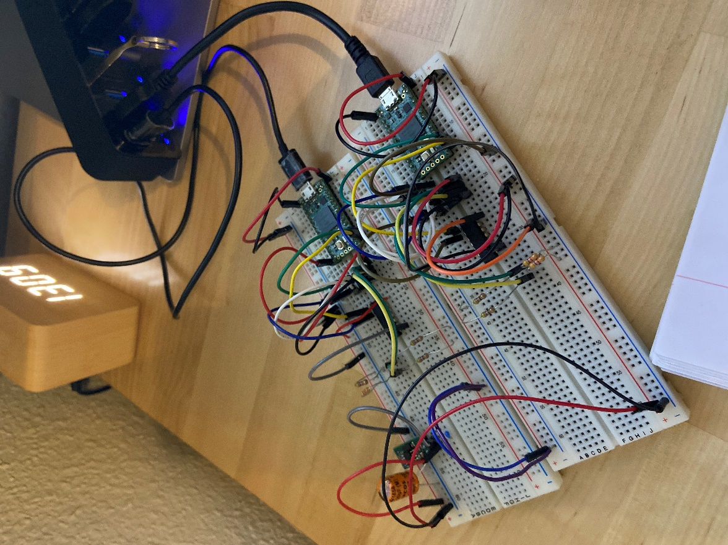

**Cover Image: Two Connected Demo ECUs**

**David Nnaji**

ENGR 580A: Secure Vehicle and Industrial Networking

Due December 17th, 2020

**1. Introduction**

Commercial trucks and trailers rely on numerous microcomputer systems called electronic control units (ECU) to exchange system information. Much of this information pertains to the operation of the vehicle and its components (i.e. performance, maintenance, and diagnostics). In order for modules to communicate effectively between each other, manufacturers have agreed on a standard practice to promote hardware and software compatibility.

Although standardization of network communication has numerous benefits overall, it has unintentionally allowed potential cybersecurity risks to become broadly applicable to commercial vehicles. In fact, academic and industry research has already demonstrated network vulnerabilities in commercial vehicles that can allow an actor to disrupt regular in-vehicle communications and functions.

While the majority of data exchanged takes place between ECUs on the truck network, semi-trailers also generate information that is routinely monitored. However, most semi-trailers on the road rely on a legacy communications standard that has been stabilized. In addition to the aforementioned vulnerabilities, the legacy communication standard has its own set of unique security challenges. As academic researchers and industry engineers work on improving the security posture of commercial vehicle communications systems, there is a need for novel demonstrations of secure communications between modules still based on legacy standards.

**2. Background**

***Related Work***

Currently, investigations into commercial vehicle network vulnerabilities, countermeasures, and other related topics are numerous, broad, and active. For example, one team of researchers used empirical experiments to demonstrate that ECMs could be disrupted through request overloads and false request-to-send (RTS) messages [1]. Recent research by the NMFTA has exposed a vulnerability within trailer power line communications (PLC) signals which indicate the possibility of remote network surveillance at distances of up to 6 to 8 feet [2][3]. A team of Michigan-based researchers developed a clock-based intrusion detection system called CIDS to identify compromised modules on the network [4].

Despite the wealth of publications available, suggested mitigations for modules based on legacy protocol are rarely mentioned or thoroughly discussed. However, many mitigations in the context of modern systems could be extended or adapted for these modules.

***SAE J1939***

Embedded communications in modern commercial vehicles are largely defined by the SAE J1939 network protocol [5]. As shown in **Fig 1**. The SAE J1939 network is modeled on the ISO/OSI protocol stack. A single message from and ECU starts at the application layer traverses down this protocol stack until it reaches the CAN-based physical layer. It is at this lower layer that messages are framed, exchanged, and ultimately traverse back up the protocol stack of another ECU to be unpacked and interpreted.



**Figure 1: J1939 Relationship to ISO/OSI Model**

A summary of notable features is provided here to avoid needless descriptions of the many documents that define SAE J1939:

Network Speed: Most often 250 kbit/s or 500 kbit/s

Network Topology: Multi-master serial bus connected via twisted wire pair with terminating resistors. Based on CAN Protocol.

Message Format: 29-bit Identifier and 8-byte data payload. As shown in **Fig. 2**, the identifier is broken into priority, reserved, data page, PDU format, PDU specific, and source address fields.



**Figure 2: Structure of 29-bit ID**

Address Claiming: Most addresses are pre-assigned to an ECU depending on its function by SAE 1939. However, an address claiming procedure has also been defined for ECU with functions beyond the scope of the standard.

Transmission: All messages sent by an ECU are visible to every node on the network. However, it is up to the receiving ECU to determine if a message can be ignored.

Transport Protocol: The procedure in place for ECUs wishing to transmit payloads larger than 8-bytes. The payload is segmented by the transmitter and put back together by the receiving ECU.

***SAE J1708 and J1587***

Embedded communication in commercial vehicles that predate the publication of SAE J1939 adhere to SAE J1708 and SAE J1587. These standards were stabilized in 2016 and their relationship to the ISO/OSI reference model is shown in **Fig. 3.**



**Figure 3: Legacy Standard Relationship to ISO/OSI Model**

Notable features of SAE J1708/1587 include:

Network Speed: Most often 9600 kbit/s

Network Topology: Multi-master serial bus connected via twisted wire pair. Based on RS-485 Protocol.

Message Format: As shown in **Fig. 4**. 1-byte Message Identifier (MID), 1-byte Parameter Identifier (PID), 18-byte (max) data payload, and 1-byte Checksum (CHK).



**Figure 4: Standard Structure of J1587 Message**

Address Claiming: Nearly all MIDs are pre-assigned to an ECU depending on its function. A dynamic address claim exists only for trailer gateway devices.

Transmission: All messages sent by an ECU are visible to every node on the network. However, it is up to the receiving ECU to determine if a message can be ignored.

Transport Protocol: The procedure in place for ECUs wishing to transmit payloads larger than 8-bytes. The payload is segmented by the transmitter and put back together by the receiving ECU.

***Feature Definition***

Description: A J1587 compliant approach for generating cryptographic keys, exchanging public keys over the network, and encrypting sensitive parameters with them. The approach should be demonstrated in-part on an analogous J1708 network.

***Threat Analysis and Risk Assessment***

In the event of system failure or malfunction, the following stakeholders are likely to be affected: driver, technician, law enforcement, researcher, general public, fleet operator and telematics. **Table 1**, provides a list of risks that could be attributed directly to deployment of a cryptographic approach. It is broken into columns containing the risk ID, description, and key stakeholders that would be affected.



**Table 1: Table of Risks**

These risks were then plotted on the matrix shown in **Fig. 5**. depending on their expected likelihood and impact.



**Figure X: Risk Matrix**

The matrix shows that risk “I” and “M” were deemed the highest threats. An attack tree for risk I shows that the potential storage of numerous keys and larger messages will lead to increased memory consumption (**Fig. 6**). To mitigate this risk, it may be necessary to increase on board memory or to use a hardware security module capable of managing many keys. Leveraging algorithms that use small keys is also recommended. An attack tree for risk m would show that larger dependency on the transport protocol for sending keys and cryptographic functions performed by an ECU could ultimately lead to increased message latency.

***Cybersecurity Goals and Concept***

1. Decrease ECU memory consumption by using 32-byte public keys generated with elliptic curve cryptography.
2. Decrease latency by incorporating a hardware security module for cryptographic functions.

***System Design Process***

A systems “V” diagram for the project with the anticipated steps and milestones is included in the appendices.

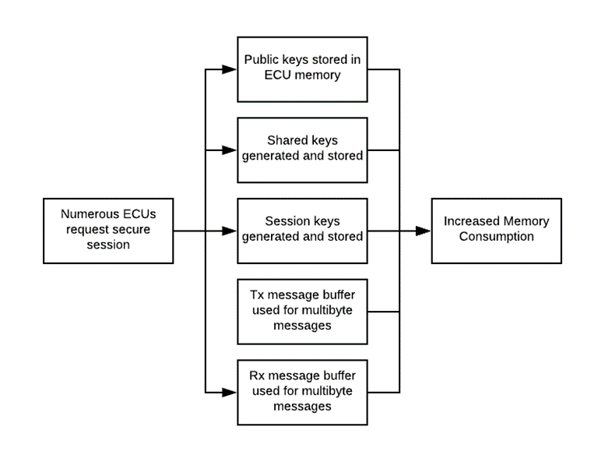

**Figure 6: Attack Tree for “Risk I”**

**3. Requirements**

The system requirements evolved as the project was further defined. The initial design alternative incorporated J1939 hardware, a software GUI, and other components. However, due to challenges with J1708 hardware leading to a diminished timeline, the following requirements we ultimately selected as the basis for the final design alternative.

**Functional System Requirements:**

**SR1** System hardware shall comply with J1708 specifications.

**SR2** Total hardware cost shall not exceed $200.

**SR3** System communication shall comply with SAE J1587 recommended practice.

**SR4** System software shall be well-documented and easy to read.

**Functional Cybersecurity Requirements:**

**CR1** System shall integrate a hardware security module.

**CR2** System shall demonstrate key-generation with HSM

**CR3** System shall demonstrate key-exchange over J1587

**4. Specific Project Focus**

This project aimed to deliver a solution for cybersecurity goals 1 and 2 mentioned earlier in the report. To accomplish this, two prototype ECUs were made using identical hardware. The primary components of the ECUs were a Teensy 4.0, an RS485 chip, hex-inverter chip, and a 5V regulator. These were integrated on a breadboard according to the wiring diagram provided in the appendices. A regulator allowed testing with an actual ECU and the Teensy allowed the device to be programmed using a C/C++ variant in the Arduino/Teensyduino IDE.

The ATECC608A was selected as the hardware security module. The Microchip TrustAuth platform development kit was used to interface with the ATECC608A via python. A diagram of the final hardware setup is provided in **Fig. 7**.

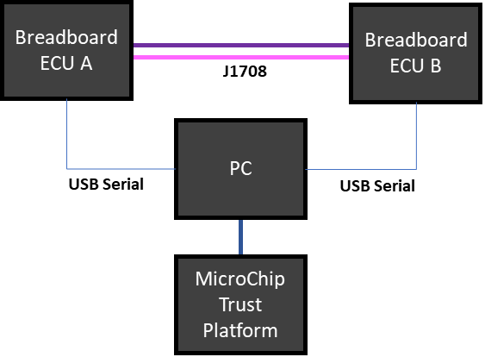

**Fig 7**: Final Hardware Setup

**5. Implementation**

***Overall Goal***

With suitable hardware in place, the two demo ECUs were intended to facilitate a demonstration of key generation, key exchange, and message encryption using the procedure shown in the appendices. This procedure produced the following deliverables:

1. One C/C++ library with useful functions for reading, and transmitting J1587 messages.
2. Two C/C++ sketches used to flash each demo ECU.
3. Two Jupyter Notebooks to generate ECC key pairs, and perform cryptographic functions using HSM and python cryptography libraries.

**Completed Source Code**

The source code that is functional and complete is the C/C++ library J1708.h and two C/C++ sketches used to flash each demo ECU. These files are available in the final submission. A general description of each function is provided in the README file. J1708Listen(), parseJ1708(), J1708Rx(), J1708Tx(), and J1708TransportTx() are among the most important functions. J1708Rx() and J1708Tx() functions were adapted from code originally written by Dr. Jeremy Daily [8].

The script written for the ECU allows it to effectively listen to messages on the serial bus, parse messages that pertain to it, queue a response, and send messages. A functional description of the code is provided in the appendices.

**Unfinished Tasks**

Two Jupyter Notebooks to generate ECC key pairs, and perform cryptographic functions using HSM and python cryptography libraries were not completed before the scheduled project completion.

**6. Testing**

**SR1: Satisfied!**

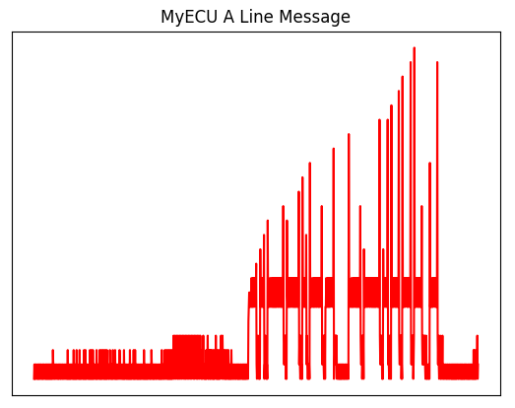

**Fig 8: Oscilloscope Capture of RS-485 Pin A Output from Demo ECU**

Despite the omission of two resistors used for signal filtering, the hardware setup for the demo ECUs satisfies SR1. This was tested by comparing an oscilloscope trace of the J7108 output signal to that of an actual ECM. This result is shown in **Fig. 8**. Additional testing using a Bendix EC60 and Caterpillar C15 module provided further verification of hardware compliance. In this test the demo ECU was connected to the J1708 pins of each ECM. The output messages that were read were then compared to a log capture with the DPA5. The wiring schematic for the demo ECUs is located in the appendices.

**SR2: Satisfied!**

A breakdown of the hardware costs to produce the two ECUs is provided in **Table 2**. The total hardware cost is roughly $76.11 which satisfies SR2.

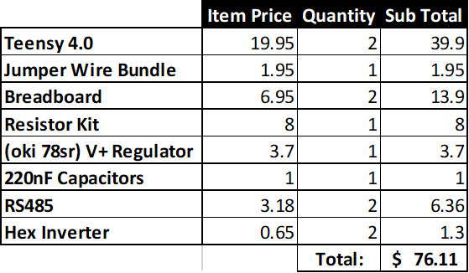

**Table 2: Itemized Hardware Cost**

**SR3 Satisfied!**

The key metrics that were used to determine J1587 were as follows:

1. Adherence to message structures defined in J1587 (MID, PID, DATA, CHECKSUM)
2. Avoidance of pre-defined MIDs and PIDs
3. Application of transport protocol to send large data packets
4. Use of request, PID pages, and other mechanism for other complex tasks
5. Appropriate message transmission rate.

The ECU code and J1708 library were written with these metrics in mind and were iteratively tested by printing their output to the USB serial port. The functions within the J1708 library in the final submission have been deemed acceptable.

**SR4 Satisfied!**

The key metrics that were used to determine that code has had been well written were:

1. The use of modularization
2. Absence of functional repetition
3. Consistent and relevant variable naming
4. Well-commented code

The ECU runtime loop consists of only 1 line of code. Key functions such as receive, transmit, and parse are separate functions that can be called the main ECU. Global variables, flags, buffers, and other data structures are named in relation to their uses and grouped at the top of the library. There are multiple instances where a third-party analyzer can read comments, and uncomment debugging code to analyze functionality.

**CR1 Satisfied!**

The hardware security module was interfaced using the ACES software.

**CR2 Partially Satisfied**

The hardware security module was interfaced using the ACES software to generate keys from the ATECC. However, these functions were not fully utilized since the final demonstration was not completed.

**CR3 Not Satisfied**

A complete run through of the software demonstration procedure was never completed. This was due to prolonged development of TransportTx() function.

**7. Vulnerabilities**

The most glaring vulnerability this specific application of cryptography to vehicle communication is verification of the public key source. Currently, any node could send its own public key with another MID. One way to minimize this vulnerability is to have a certificate authority. The certificate authority is an entity that issues digital certificates that certify the ownership of a public key by the certificate owner. Actually, implementing this in a vehicle system would be challenging since any OEM could assume the role of CA.

**8. Reflection**

My project was ambiguously defined for an extended period of time which ultimately lead to a final result that was somewhat less than what I had hoped for. One of the glaring issues I had was identifying a specific problem I wanted to analyze. Aside from this, I was also learning a lot as my project evolved. Early on, I knew I wanted to use cryptography is some way but I did not have the technical examples to draw from until a lecture example was available. Despite this, I am glad I was challenged and didn’t default to an easier project. Looking back, I have gained the following:

1. A better understanding of cryptographic tools, how to use them, and their applications (particularly to vehicle systems).
2. A chance to practice C++ on an actual project outside of Codecademy!
3. Strong understanding of SAE J1708/1587 based systems.

**9. Works Consulted**

[1] S. Mukherjee, H. Shirazi, I. Ray, J. Daily and R. Gamble. (2016). "Practical DoS Attacks on Embedded Networks in Commercial Vehicles" Internet: www.cs.colostate.edu. Dec. 16, 2020.

[2] K. Cho and K. Shin. (2016). “Fingerprinting Electronic Control Units for Vehicle Intrusion Detection” Internet: [www.usenix.org](http://www.usenix.org). Dec. 16, 2020.

[3] Cybersecurity & Infrastructure Security Agency. “ICS Advisory (ICSA-20-219-01)”.Internet: [us-cert.cisa.gov](https://us-cert.cisa.gov/). Dec. 16, 2020.

[3] Cybersecurity & Infrastructure Security Agency. “ICS Advisory (ICSA-20-219-01)”.Internet: [us-cert.cisa.gov](https://us-cert.cisa.gov/). Dec. 16, 2020.

[4] DEFCONConference. “DEF CON Safe Mode ICS Village - Ben Gardiner - PowerLine Truck Hacking 2TOOLS4PLC4TRUCKS” Internet: www.youtube.com/DEFCONConference. Dec. 16, 2020.

[5] Society of Automotive Engineers. SAE J1939. (2018). Dec. 16, 2020.

[6] Society of Automotive Engineers. SAE J1708. (2016). Dec. 16, 2020.

[7] Society of Automotive Engineers. SAE J1587. (2013). Dec. 16, 2020.

[8] “J1708.” Github. Internet: [github.com/jeremydaily/J1708](https://github.com/jeremydaily/J1708) Dec. 17, 2020.

**10. Appendices**

***Systems “V” Diagram for Class Project***

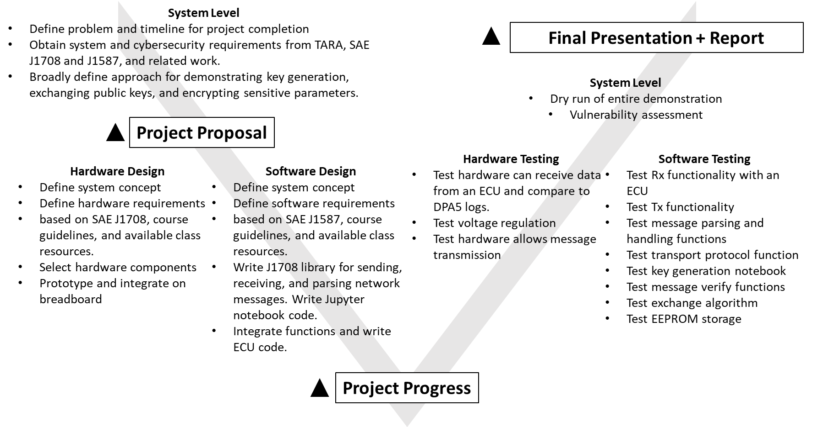

**Wiring Schematic for ECUs**

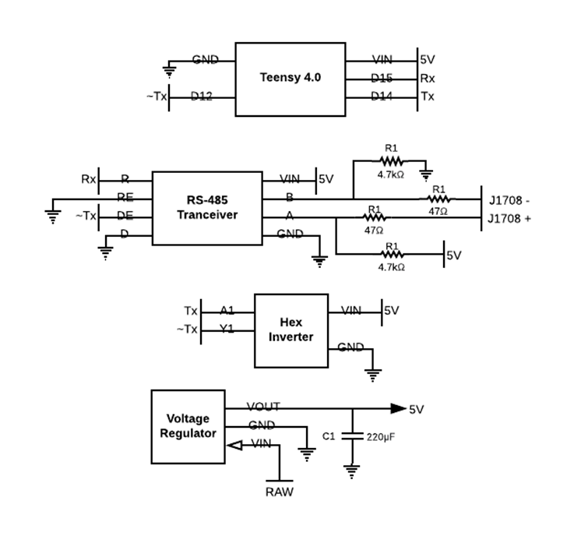

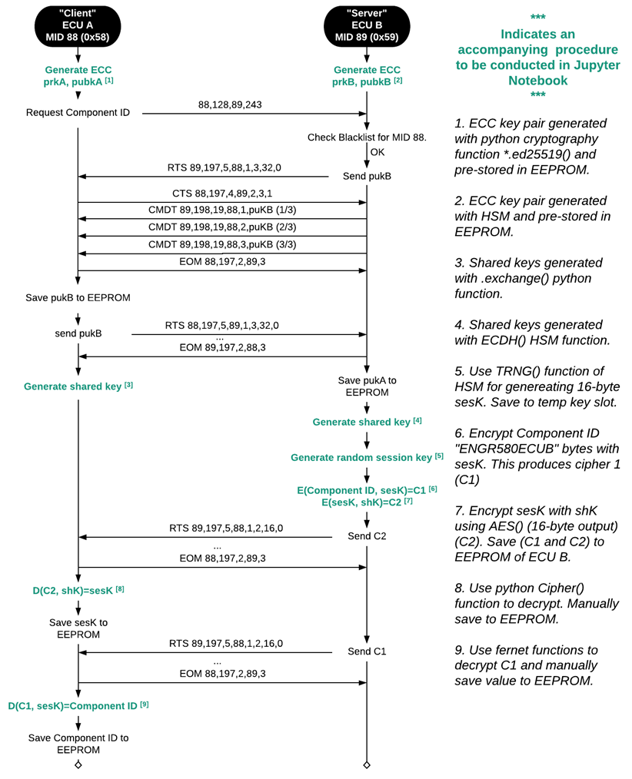**Software Demonstration Procedure**

**ECU Runtime Algorithm**

